Preliminary Assessment for a 9/11 Geospatial Archive

By: Noreen Whysel

For: Fund for the City of New York

### 9/11 Geospatial Archive Assessment

The main activity of the 9/11 Geospatial Archive Assessment was to identify and meet with institutions, agencies and individuals who may hold 9/11 artifacts and assess the extent of existing material and willingness to donate or receive archived materials, and to identify materials that can be donated and/or reproduced, for example digital files, storage media, physical maps, correspondence and other documentation related to the rescue and recovery efforts at the World Trade Center after the September 11, 2001 attacks. These items would form the basis of a 9/11 Geospatial Archive (the Archive) to be developed as a flagship project of the Center for Geospatial Innovation.

The Center for Geospatial Innovation (the Center) is proposed as a premier center created to support research and education related to geospatial technologies in New York City and nationwide. We feel that the Archive would be a key component of the Center’s activities and also, given the national interest in 9/11 history, would represent a jewel around which the Center could promote its activities and seek funding for its operations. New York City, and the United States overall, has not experienced a more devastating and impactful event than the attacks of September 11, 2001 since Pearl Harbor. The effort to respond to the disaster was unprecedented in New York City and produced technological advancements and a collaborative model that may not have been possible under normal conditions. It is our goal that the Archive will serve to document this historic moment and the heroic efforts of the personnel and volunteers who participated in the rescue and recovery.

We have created a list of over 650 items that have been described in a Google document:

<https://docs.google.com/spreadsheets/d/1Gbpz1WXIjgWrzlEZzTbqT4NrbBVUY61EU8usclT1gNE/edit?usp=sharing>

Included in this spreadsheet is item level description for materials that have been collected by the research team, archivist Noreen Whysel and Center for Geospatial Innovation Director Alan Leidner. Electronic materials have been saved to a Dropbox account.

* What institutions hold 9/11 geospatial artifacts
* Who is responsible for the artifacts at their institution
* Format (digital/physical) of the existing artifacts
* Physical condition of the artifacts
* Ownership the artifacts (can the artifacts be donated or duplicated)
* Sensitivity of the materials (public, confidential, secret)
* Institution’s retention policy for the artifacts

### Project Plan

The plan for the assessment included developing contact list and setting up meetings with potential partners, donors and repositories to review holdings and capacity. We were able to connect with over two dozen people who were physically present on Pier 92 and had some involvement with producing or recording geographic materials during the 9/11 rescue and recovery efforts and subsequent research and analysis. People who were involved with the following government agencies, companies and institutions have been interviewed and a number of materials have been collected assessed:

* NYC Emergency Management Department
* NYC Parks Department
* NYC Department of Health and Mental Health
* NYC Department of Information Technology and Telecommunications
* Fire Department of New York
* Metropolitan Transit Authority
* New York Transit Authority
* New Jersey Office of Emergency Management
* NYC Department of Environmental Protection
* FEMA
* New York State Office of General Services
* National States Geographic Information Council
* Centers for Disease Control
* Hunter CARSI Lab
* Urban Logic, Inc.
* Plangraphics
* ESRI
* Westchester County GIS
* Bowne Group
* US Department of Homeland Security

We have also connected with institutions both public and private that have materials related to the event, which we may wish to link from our digital archive. Some of the initial tasks were to visit and describe existing 9/11 physical and digital archives and repositories. The following institutions were contacted. (Not all were visited):

* [George Mason University: The September 11 Digital Archive](http://chnm.gmu.edu/the-september-11-digital-archive/) (Sharon Leon)
* Columbia University: 9/11 Oral History Project
* Columbia University Spatial Data Center (Laura Kurgan)
* Internet Archive: Understanding 9/11 - A Television News Archive
* Government Agencies:
  + NYC Municipal Archives
  + NYC Emergency Management
  + NYC DoITT
  + NYPD/FDNY
  + FEMA, DHS, NOAA, NARA and other federal agencies
  + Agencies and institutions involved in rescue/recovery at the Pentagon and Flight 93 PA crash site
* Museums:
  + 9/11 Memorial and Museum
  + HY Historical Society
  + Museum of the City of New York
  + Firemen’s Museum
  + NYPD Museum
  + Intrepid Museum

Report on size of potential collection and interest in either donating materials to a future physical archive or receiving materials. Report on creating digital-only collection, or clearinghouse of existing materials.

### Archival Policy Statement

#### Vision Statement

The 9/11 Geographic Archives will serve as a documentation of the heroic efforts by geographers in response to the September 11, 2001 attacks.

#### Mission Statement

The mission of the 9/11 Geographic Archives is to collect, exhibit, interpret, preserve and provide public access to geographic materials produced during the rescue and recovery efforts after the September 11, 2001 attacks. The materials collected and preserved represent important historical artifacts of the efforts of the geographic community in New York City and their interaction with local, regional and federal agencies. The initial collection will focus on the World Trade Center attack in New York City, but may extend to the Pentagon and Flight 93 sites. This period of time represents a pivotal moment in the advancement of geospatial and emergency management technologies. As such the Archive will further serve to document the state of geospatial technology before, during and after September 11, 2001 and advancements in geospatial tools and processes supporting emergency management efforts through today.

#### Responsibility

The 9/11 Geographic Archives is a flagship project of the Center for Geospatial Innovation and oversight lies with the Center’s leaderships, including director, Alan Leidner, who served as Assistant Commissioner and GIS Director of the NYC Department of Information Technology and Telecommunications at the time of the attacks. The Center is currently co-located at the Fund for the City of New York, 121 Avenue of the Americas.

#### Regulations

The Archive may be subject to certain regulations, which we are currently researching. Since some of the material collected by the Archive may fall under copyright restrictions or require security clearance, the Archive will be governed by relevant New York City or Federal regulations. All materials will be reviewed and to the best of our ability we will determine copyright, ownership and appraised value. If it is determined that ownership of any materials precludes the item from accession into our collection, we will attempt to deliver the materials to their rightful owner. We will attempt to obtain the right to hold copies any such materials in the Archive as allowed by the owner. The Archive will do its best to determine ownership, this may not be possible. In that case, item descriptions will include a statement of inconclusive copyright, similar to the statement used by the New York Public Library. Original contributors of any materials will retain copyright of the materials donated to the collection.

Certain materials that the Archive acquires from personal collections may be subject to security clearance regulations. Where there is a question, these items will not be offered for public access until such determination can be made. So far we have not collected any items that appear to be under a security restriction.

#### Accepted Materials

The Archive will accept materials that reflect its mission, specifically maps, data, correspondence, written documentation, manuscripts, monographs, journal articles, oral histories, videos, presentations and other materials related to the geographic efforts of the rescue and recovery operations, volunteers. Currently over 650 Items of physical and digital media exist the collection.

#### External Materials

The Archive will document and link to a number of external collections and materials and provide metadata and access information, where available. As additional collections are discovered and documented, these will also be added to our database. These collections include materials held at the 9/11 Memorial and Museum, the New York City Municipal Archives, the New York Public Library, George Mason University, Columbia University, the Museum of the City of New York, the New York Historical Society, the National Archives and Records Administration, the Library of Congress and other public and private institutions.

#### Access

Access to the Archive will be available to researchers, emergency managers, geographers and the public by appointment. Digitization of materials will help extend the reach of the collection by offering online access to materials and item metadata where feasible and permitted by copyright.

### Facilities and Staffing Plan

#### Physical Storage

How much physical storage space is needed is determined by the number and size of materials to be collected. Most of the materials collected are digital and are saved to cloud media, which only requires an internet-connected device to access. The Archive assessment team has collected two cubic feet of physical materials including videotapes, CDs, DVDs, thumb drives and paper materials. We may accession additional physical materials which will increase our storage needs. Recent conversations with David Lashell uncovered a number of paper maps and other physical records that were retrieved from ESRI when one of their New York offices closed. David offered to provide details at a later date.

#### Digital Storage

The Archive contains a little over 600 digital files stored on DVDs, CD-Rs, and thumb drives. These files have been copied and stored on cloud media, including Dropbox and Google Drive. At least one of the CD-Rs appears to have read problems. Files on the damaged CD-R have not been copied to the cloud.

Five VHS videotapes that appear to contain oral histories of geographers and other responders from the Office of Emergency Management. These have not been examined but may contain or complement footage that George Davis recorded and has copied to DVD. The condition of the videotapes has not been assessed; however, Bruce Cahan of Urban Logic, Inc., who originally created them, has confirmed that a short documentary was produced and burned to CDs and were delivered to all members of Congress. It is possible that some of the CDs may have been accessioned by the Library of Congress, but we have not followed that trail yet.

Digital master copies of all files stored on physical media should be created by a professional digitization service if one is not available at the Center or FCNY. The Metropolitan New York Library Council (METRO)l has a new digitization service available to members, which we can look into using. Institutional membership is $494 for institutions with less than $99,000 in operating expenses. Individual membership is $100 per year. We have not requested a proposal for digitization services and the fees are not listed. METRO also has a list of materials for creating a do-it-yourself, mobile digitization service with items and costs. It may be more economical to outsource.

#### Staffing

Currently a part time archivist is all that would be required to assess and maintain the collection. Digitization can initially be provided by services such as those available at METRO or via a future arrangement with NYPL or other holding institution. As the Center is developed and researchers begin to use the collection, full time staff will be required to further develop and support the collection and its users. A full time grant writer would be helpful in obtaining funding for capacity building, digitization and preservation and could be shared with the Center’s other projects.

#### Funding

Initially, the Fund for the City of New York is providing funding for a consultant to assess the collection and draft a archival policy. Additional funding may be available from FCNY and other funders. Similar projects such as George Mason’s September 11th Digital Archive have secured funding from the following organizations:

* [Alfred P. Sloan Foundation](http://www.sloan.org/)
* [Andrew W. Mellon Foundation](https://mellon.org/grants/) cultural history grants
* [American Social History Project](http://www.ashp.cuny.edu/) at the City University of New York Graduate Center
* [Saving America's Treasures Grant](http://www.nps.gov/history/hps/treasures/) from the [National Park Service](http://nps.gov/) supported George Mason’s September 11th Digital Archive project
* [National Endowment for the Humanities](https://www.neh.gov/grants) offers grants for preservation assistance, digital access and capacity building, among others
* The [National Archives](https://www.archives.gov/nhprc/announcement) offers several grants for access and engagement with historical records
* [American Geographical Society](http://americangeo.org/submitting-research-and-special-project-proposals/) offers special project funding to members
* [United States Geospatial Intelligence Foundation](http://usgif.org/) may offer some funding
* [Institute of Museum and Library Services](https://www.imls.gov/grants)
* [Advisory Council on Historic Preservation](http://www.achp.gov/funding-cultural.html) lists a number of additional resources
* [ESRI](http://www.esri.com)

We are continuing to research additional funding sources, including technology incubator programs at local universities, including The Bridge at Cornell Tech, NYU’s GovTech and others.

### Items

Items collected to date include map images, map project files, aerial photography, LIDAR and thermal images, presentations, video interviews, oral histories, written meeting notes, agendas and signing sheets, documentation of daily activities on Pier 92, assessments and analyses, among other materials. A total of 625 items have been described in a Google spreadsheet at: <https://docs.google.com/spreadsheets/d/1Gbpz1WXIjgWrzlEZzTbqT4NrbBVUY61EU8usclT1gNE>

The items are arranged by the collection donor and the media they were saved on, but can be curated into collections including the following:

* WTC and Lower Manhattan pre-9/11
* Plane impacts, collapses, dust cloud
* First maps produced by FDNY
* Aerial imagery of WTC site – series
* South of Canal Street Access - series
* Utility outages – series
* Thermal imagery showing underground fires – series
* Transportation status – series
* Deep Infrastructure Group images: WTC basement levels, bathtub, etc.
* Photos and maps of subway damage and outages
* FEMA maps
* EPA maps of environmental conditions
* LiDAR imagery from CARSI and NYS GIS
* Maps put on line for the public – series
* GISMO Yahoo Group discussion list archive

### Resources

The following section outlines research into items that we have collected or that may exist in private and personal collections.

**GeoSymposium 2001-2011-2021**

GeoSymposium 2001-2011-2021 was a single day program held at the annual Technology in Government program hosted by the New York City Department of Information Technology and Telecommunications. Three sessions included presentations covering before, during and after 9/11. Alan Leidner has shared the presentations, which were incorporated into a single PPT and added to the item list. Individual presentations are also on a removable drive and have been copied to the cloud.

**Hunter College CARSI Laboratory**

Sean Ahearn, Hunter CARSI lab,

* Handheld mobile gis app for rescue, recovery (IBM affiliate Linkpoint, Roderick Rae's, IBM or Bill Johnson, retired NYS GIS may have copies and/or devices)
* LIDAR imagery

Jim McConnell, NYC EM (sent email 1/13/17)

* Meeting with Alan and Jim at EM on 3/22/2017
* He has all maps produced at EMDC in PDF but needs to check with legal on access.
* I followed up 5/4/2017 but have not had an answer yet.

George Percivall, OGS

* Still at OGS, connected on LinkedIn
* OGC did a project responding to challenges that were encountered during 9/11 response. He worked with Allen to shape the project.
* He's sending info.

Wendy says DEP may have

* Satellite imagery
* Pedestrian/vehicular access
* Heat maps, thermal sensing, freon tanks
* Map request tracking application (Excel)
* Modification of EMOLS, for public information
* River crossings, ferry service, bridges
* BIN maps, first assignment?
* Building status, inspections, mobile app DOB Red Zone (IBM)
* Human remains, personal effects, mobile app

Deep Infrastructure Group (DIG) -

* watermains, sewers, freon tanks status
* Electric, telephone outage
* Aerial photography
* NYC Trade Waste Commission

FDNY

* Steve Pollackov (sent email 1/17/17, he gave me Mike Brady’s cell number),
* Chang Chung (no longer with FDNY) presented FDNY materials to GISMO at a 2003 meeting including:

1. PHOENIX, The FDNY GIS Unit.  
2. WTC operations map gallery in chronological sequence.   
3. Q & A.  
4. Discussion of future GIS applications for emergency preparedness and  
management.

Ronald Langhelm, FEMA dr-1391-ny

Dan McHugh NYTA (sent email 1/17/17, no response, Don Willemon says he is still there)

* Don suggests Bob Shevlin ([Robert.Shevlin@nyct.com](mailto:Robert.Shevlin@nyct.com)) but it looks like both he and Dan have retired. Dan may still use: [DanMcHugh@aol.com](mailto:DanMcHugh@aol.com).
* Steven.Ceyko@mtahq.org works in Dan's old group. Not sure if he would know 9/11 history.
* Cortlandt IRT subway damage assessment

Don Willemon, MTA

* Greg Kurilla for MTA B&T, Possibly Rachel Arulraj
* Don wasn't involved. He got interested in GIS post 9/11 after Pier 92.

Department of Health

* Ed Carubis, was DoH, moved to ESRI, Redlands - ecarubis@esri.com
  + Data and maps on West Nile, Anthrax scare
* Susan Resnick (sent email 1/17/17) now at DoH
  + 9/11 Health Registry <http://www1.nyc.gov/site/911health/index.page>
  + CDC requested maps and records for a 9/11 archive, she's checking on contact there
  + Recommends contacting the press office [Pressoffice@health.nyc.gov](mailto:Pressoffice@health.nyc.gov)

Paul Katzer, Parks Department

* OEM, Flight Crash 587, mobile computer, plotter
* Gave rise to Mobile data center
* Left Parks for OEM, then Pfizer. Currently risk management at Deutsche Bank
* Ask Jim about the mobile app first. It may be archived with OEM.

Sam Wear, Westchester GIS

* May have one map

Bruce Cahan:

* Interviews on VHS. Bruce gave his permission to duplicate to stable media, and to send to him copies if we do.
* Bruce says that clips from the videos were burned to DVD and delivered to all Members of US Congress around the time that they voted on funding for recovery efforts. I didn't see a record of a DVD at LOC.gov, but am not sure how it would have been catalogued. I will check with NYS reps offices to see if they have any record of it.
* He suggested additional materials to look for:
  + Records of map requests from intake desk, analysis by time frame, requester (Wendy has a PPT showing what was produced each day. Alan says ESRI may also have these.)
  + Navigation charts for Flight 587. He said that Alan Leidner had these on his CDs.

Email from Bruce Cahan:

Hi Noreen:  
  
Wonderful to hear from you after so many years.  
  
As you may recall, in the early 1990s, through my nonprofit Urban Logic, I championed what become NYCMAP, and pushed for the capital budget to support Alan’s organizing it. By the mid-1990s, the OMB, FGDC, USGS, EPA and other federal agencies wanted me to help financial shared geospatial data infrastructure at national and international levels.  
  
So when 9/11 happened, I had federal mapping allies, and through them (FGDC), my laptop downloaded the first photogrammetry of Ground Zero. I carried it over to Sean Ahern’s CARSI Lab at Hunter College and we walked the printouts to the Police Academy at 20th & 3rd by mid-afternoon on 9/11.  
  
I instigated shooting the videos you have in your hand. because of the post-9/11 corporate ad/promotional campaigns claiming that their various products and teams mounted or responsible for the Emergency Response.   
  
I felt that the foresight and ingenuity of government leaders/innovators like Alan needed to be captured in first-person oral history accounts so that the role of GIS, and as importantly, the GISMO and other informal networks of trust that preceded 9/11, could be preserved and featured.  
  
I reached out to the Council for Excellence in Government (CEG) who agreed to fund videotaping the interviews of principal players.  
  
The filming took place in my office in the Financial Times Building at 54th & 6th, and at Pier 92.  
  
I drafted the “shooting script” and oversaw editing the documentary, which CEG pressed onto DVDs and distributed to all Members of Congress (Senators & Representatives) as a means to promote awareness on Capitol Hill of federal agencies and responders relying on the role of GIS and local government technology partnerships.  
  
CEG disbanded in 2009 after having some financial issues: http://www.govexec.com/oversight/2009/02/council-for-excellence-in-government-to-close/28530/  
  
I also partnered with the SUNY Center for Technology in Government (CTG) to research and write several papers as an NSF-funded study based initially on the interviews conducted in the videos, such as this paper: http://journals.sagepub.com/doi/abs/10.1177/0894439303259887 http://dl.acm.org/citation.cfm?id=976027  
  
As with so many groups that wanted to champion their connections with 9/11 response and responders, the collaborations with CEG and SUNY CTG were short-lived opportunistic exercises, and they went on without Urban Logic to promote their research on topics originally of mutual interest.  
  
When I moved from NYC, I believe I recall donating some of my 9/11 Emergency Mapping & Data Center (EMDC) and other NYCMAP materials to Alice Hudson in the Map Room at NY Public Library.  
  
Alan went on to Booz Allen and other consulting assignments, as befits the government innovator he always has been and is.  
  
I would like to have digital copies - once transferred - of the VHS tapes, and any other digital materials about my connection with 9/11, whenever you can send them along or upload them to a DropBox folder.  
  
All the best,  
  
Bruce  
  
Bruce Cahan  
Cell: (212) 399-9700  
bcahan@urbanlogic.org | bcahan@stanford.edu  
Skype: bbcesq  
Twitter: brucecahan

Dave LaShell, ESRI

* Has paper maps, DVDs, data and materials from the old ESRI downtown office in his attic. When they closed the office, rather than try to sell or archive materials, they let the office managers keep them.
* Dave confirmed that Chris Scheilein has the request and staffing databases and a lot of maps and other materials.
* Dave said ESRI is very interested in expanding sponsorship of activities like ours and would be interested in funding this project.
* He can get us vintage copies of the ArcGIS software. He told me that 9/11 happened around the time of a new version of the software, but no one liked the new program, so most stuck with version 3.0. Probably would have run on XP. I have a Dell laptop with XP. We may be able to get additional donations of vintage computers to run and/or emulate the older ArcGIS software.
* Dave wants to write a couple paragraphs about his experience and recollections to archive with the collection.

Alan Leidner, Booz Allen Hamilton presentation, implications for mapping future emergencies

* Alan has list of contacts from Emergency Management Data Center and ESRI hours list. (Dave Lashell says Chris Scheilein has the rosters too).
* Alan has provided several DVDs and CDs of data, maps, PPT presentations and photos.

AAG/AGS:

* Geography AP course Informati

Anthony Cocciolo, Professor, Digital Archives, acting Dean, Pratt iSchool

* Objects and memory documentary (9/11)
  + Shows people who collected items
* Thumb drive containing his paper on cell phone memorial, listening to stories, lists references
* He suggests doing a literature search on JSTOR on Archiving and 9/11 and capturing for a LibGuide to external holdings

**Wendy Dorf, DEP**

* Speeches/stories from GeoSymposium, budget
* Look for *9/11* documentary directed by Jules and Gedeon Naudet, and FDNY firefighter James Hanlon.
  + They were originally following the lives of a plebe (junior fireman) assigned to Duane st firehouse. Responded to WTC with cameras.
  + <https://en.m.wikipedia.org/wiki/9/11_(film)>
  + Joe Pfeiffer led operation, decided who went where when. His brother died and he kept working.
* RW Greene, ESRI, *Confronting Catastrophe*, a GIS guide
  + Alan has a copy, can get one from ESRI
  + Vertical infrastructure project came out of what was studied
  + Wendy’s essay was included
* Wendy suggested additional resources:
  + NYCTA, CD-ROM of subway stations (Don Willemon, Dan McHugh, Edmond Bond was formerly of CAD-Retired, Bruce Siahpoosha, Frank Maffei, Mohan Gujarati)
  + DEP Utilities, Paul Bennett now chief of emergency planning at DEP
  + Coned- Eric Stewart, retired (son may be there? Someone with his name
  + Keyspan - Mike Rogers
  + Army Corps of Engineers- Steven McDevitt, retired
  + LIRR, Chris Powers
  + John Griffin, DoT
  + List of daily updates and who was assigned
  + URS consultants, Kay Adams Manion, brought engineers to do deep infrastructure, still at URS
  + Rebecca Clough DDC., now asst commissioner of DDC Justice Triad (works for Feniosky)
  + Chris Schelein, ESRI, may have access to the request database. Dave confirmed he has it.

Yahoo email list and files with 9/11 resources

* I downloaded the full message list. Can be mined for information around planning, volunteer coordination, presentations related to rescue/recovery.

**Exhibitions**

September 7 – October 26, 2002

Witness and Response: September 11 Acquisitions

Library of Congress, Geography and Map Division

<https://www.loc.gov/exhibits/911/911-maps.html>

City of New York & CARSI  
February 1 – February 28, 2002

Woodward Gallery

Charting Ground Zero: Before and After

September 7 – October 23, 2011  
National September 11 Memorial and Museum

Charting Ground Zero: Ten Years After

<http://woodwardgallery.net/exhibitions/charting-ground-zero-ten-years-after/>

There is also a videotape of the exhibit that Sean did with Woodward. Harvard has a copy. It includes a Channel 11 interview and footage of the 2002 Woodward Gallery show. PlanGraphics was a sponsor of the original exhibit.

Charting Ground Zero

Sep. 07, 2011 - 6:53 -

Sean Ahearn interview on Fox News. “New York professor's mission after September 11th”

<http://video.foxnews.com/v/1147489752001/?#sp=show-clips>

#### Externally Held Resources

New York Public Library: NYPL holds a number of maps created by Columbia University professor Laura Kurgan who directs the Center for Spatial Research at Columbia’s architecture school.

Hunter College CARSI Lab: Maps and video created by CARSI were exhibited at the Woodward Gallery in New York City on February 2002 and again in October 2011. These have been donated to the 9/11 Memorial, according to CARSI Director Sean Ahearn. Harvard University holds a copy of the video and a news clip was produced by Fox News on September 8, 2011 interviewing CARSI Dr. Ahearn.

9/11 Memorial: In addition to the CARSI materials, the 9/11 Memorial and Museum holds artifacts and data which may be of interest to our users. Noreen Whysel has connected with the archivist at the museum and submitted a request to examine the collection. We are waiting for confirmation of a visit.

New-York Historical Society: The NY Historical Society has a collection of images that document the history of the World Trade Center from its initial design to construction and management.

Museum of the City of New York: The museum holds 5 photographs and one print of a *New Yorker* magazine cover in its 9/11 Objects collection. Its “Here is New York” collection has 4 boxes and one flat file full of photographs that include images of the World Trade Center before and after the attack.

George Mason University: The September 11th Digital Archive contains first-hand accounts, emails and other electronic communications, digital photographs and artworks, and a range of other digital materials related to the attacks.

The Port Authority of NY/NJ: The Port Authority has materials of interest that will be documented and referenced. We have not yet secured a visit with their archivist.

National Archives and Records Administration: The New York office of NARA holds Coast Guard maps depicting shoreline access restrictions. The Maryland office contains a large number of documents, transcripts, maps and other materials related to the 9/11 Commission which may be relevant. These are cataloged online, but only available to examine on-site.

Flight 93 Memorial: ?? Does Pentagon have a memorial? Or would it be their records people to contact?

#### Geospatial Archives - General

Julie Sweetkind-Singer, Stanford University, “Digital Collection Decisions: A National Geospatial Digital Archive Perspective”

Steve Morris, North Carolina State University, Map Material At Risk

Video Presentation: <https://www.loc.gov/today/cyberlc/feature_wdesc.php?rec=4116>

Presentation Transcript: <https://www.loc.gov/today/cyberlc/transcripts/070625osi1330panel(ed).doc>

#### Resources for Collection Development and Grants

A number of professional societies at the local, state and national level offer resources to archivists in developing geographic collections.

* Society of American Archivists
* National Archive and Records Administration
* Council of State Archivists
* Special Libraries Association
* ARMA International
* American Library Association, Mapping and Geographic Round Table (map SIG), Louise Ratliff, lratliff@library.ucla.edu
* METRO, Kerri Willette, Deputy Director
* Illinois State Proposal for a Digital Archive http://ir.library.illinoisstate.edu/fpml/75/

#### Institutions

**DPLA**: Digital Public Library of America, Anne Karle-Zenith

Seeking to expand cartographic content. <http://dp.la>

Only take item level data, not collection.

Current 9/11 Holdings: <https://dp.la/search?subject=September+11+Terrorist+Attacks%2C+2001>

**NYPL**, Phil Sutton (collection), Matt Knutzen (historical memory)

* Phil believes they got a donation of 9/11 materials, but that they were not well catalogued. He may be referring to the Columbia spatial center maps by Laura Kurgan, or other maps.
* Bruce Cahan recalls donating materials to Alice Hudson in the Map Division. These may include Center for Technology in Government materials and documents described below.
* September 11 Terrorist Attacks - 2001-- Maps

<http://browse.nypl.org/iii/encore/search/C__SSeptember%2011%20Terrorist%20Attacks%2C%202001%20--%20Maps.__Orightresult?lang=eng&suite=def>

**9/11 Memorial**

Alexandra Drakakis, associate curator, adrakakis@911memorial.org

Isabelle Brand, exhibition staff, [isabella.f.bruno@gmail.com](mailto:isabella.f.bruno@gmail.com), ibruno@911memorial.org

* I submitted a research request. No response as of May but it says it can take up to 90 days.

**NARA**

Kelly McAnnaney, kelly.mcannaney@nara.gov

* Coast Guard, a series of Incident Command Planning Documents Related to Sept. 11, 2001
* Kelly says there may be more in the College Park, MD Archive and suggests searching “September 11” at <https://catalog.archives.gov/advancedsearch>. Search filter “maps and charts”
  + 2,840 total records in search “September 11” after 9/11/2001
    - Most (2000+) are photographs
    - 157 documents, primarily 9/11 Commission transcripts
      * There appear to be many more items within the 9/11 commission series that use the term “September 11” including mostly interview transcripts and audio recordings.
    - 3 are 9/11 Commission interviews
    - 1 film clip of a 34c commemorative stamp unveiling
* 9/11 Commission has several series that include records that mention maps.
  + May need to search individual series, I'm getting a lot of timeout errors.
  + <https://catalog.archives.gov/search?q=Map&f.oldScope=(descriptions%20or%20online)&f.descriptionPOName=National%20Commission%20on%20Terrorist%20Attacks%20Upon%20the%20United%20States.&SearchType=advanced>
* Records are generally turned over to NARA by agencies when they are ready to be archived, which can take 20 years. So we may be a few years away from seeing them come in.
* I expect to go there during the second week of May to view the Coast Guard materials and will ask questions about accessing procedure for FEMA, CDC, DOD and other agencies that participated at EMDC.

**NYC Municipal Archives**

Sylvia Kollar, Archives Director

Rossy Mendez, Reference Archivist

* Rossy sent some info but has asked an accessioning archivist to contact me about policy. Sounds like it's similar to NARA. Agencies may keep their own archives and could be years or decades, if ever, before they are sent to 31 Chambers.
* Sylvia says State Archives in Albany has digital photographic records of aerial views above lower manhattan.   
  NYC MA collections has a lot of artifacts and memorabilia: <http://www.nyc.gov/html/records/html/archives/collections_wtc.shtml>
* Includes an extensive photograph collection that may be helpful.
* Sylvia invited me to make an appointment to come in and research the collection.

#### Sample Assets

The following is a sample of the types of materials currently held in our digital and physical collection.

Maps and Aerial Photography

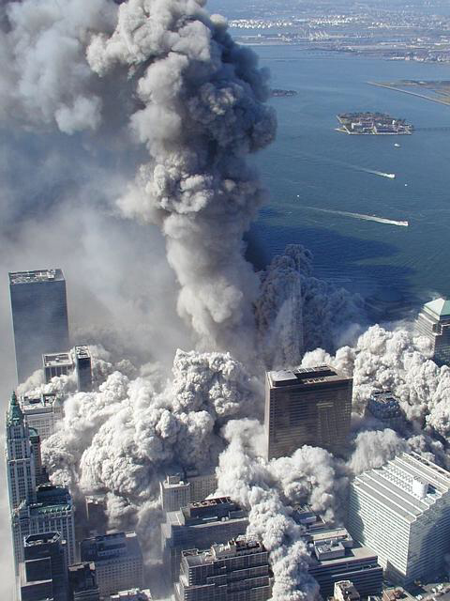,

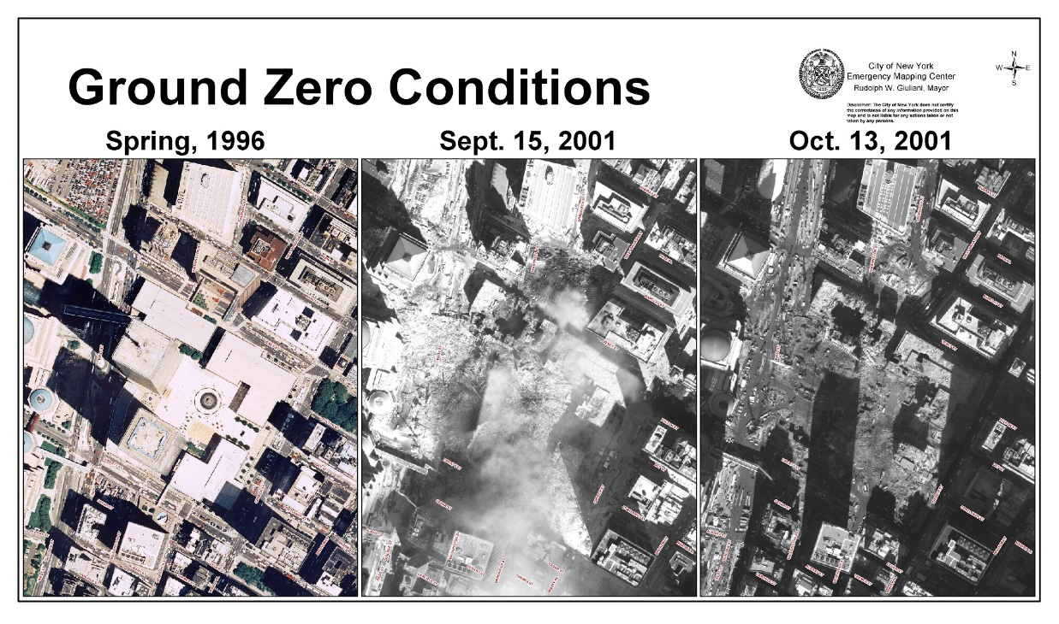

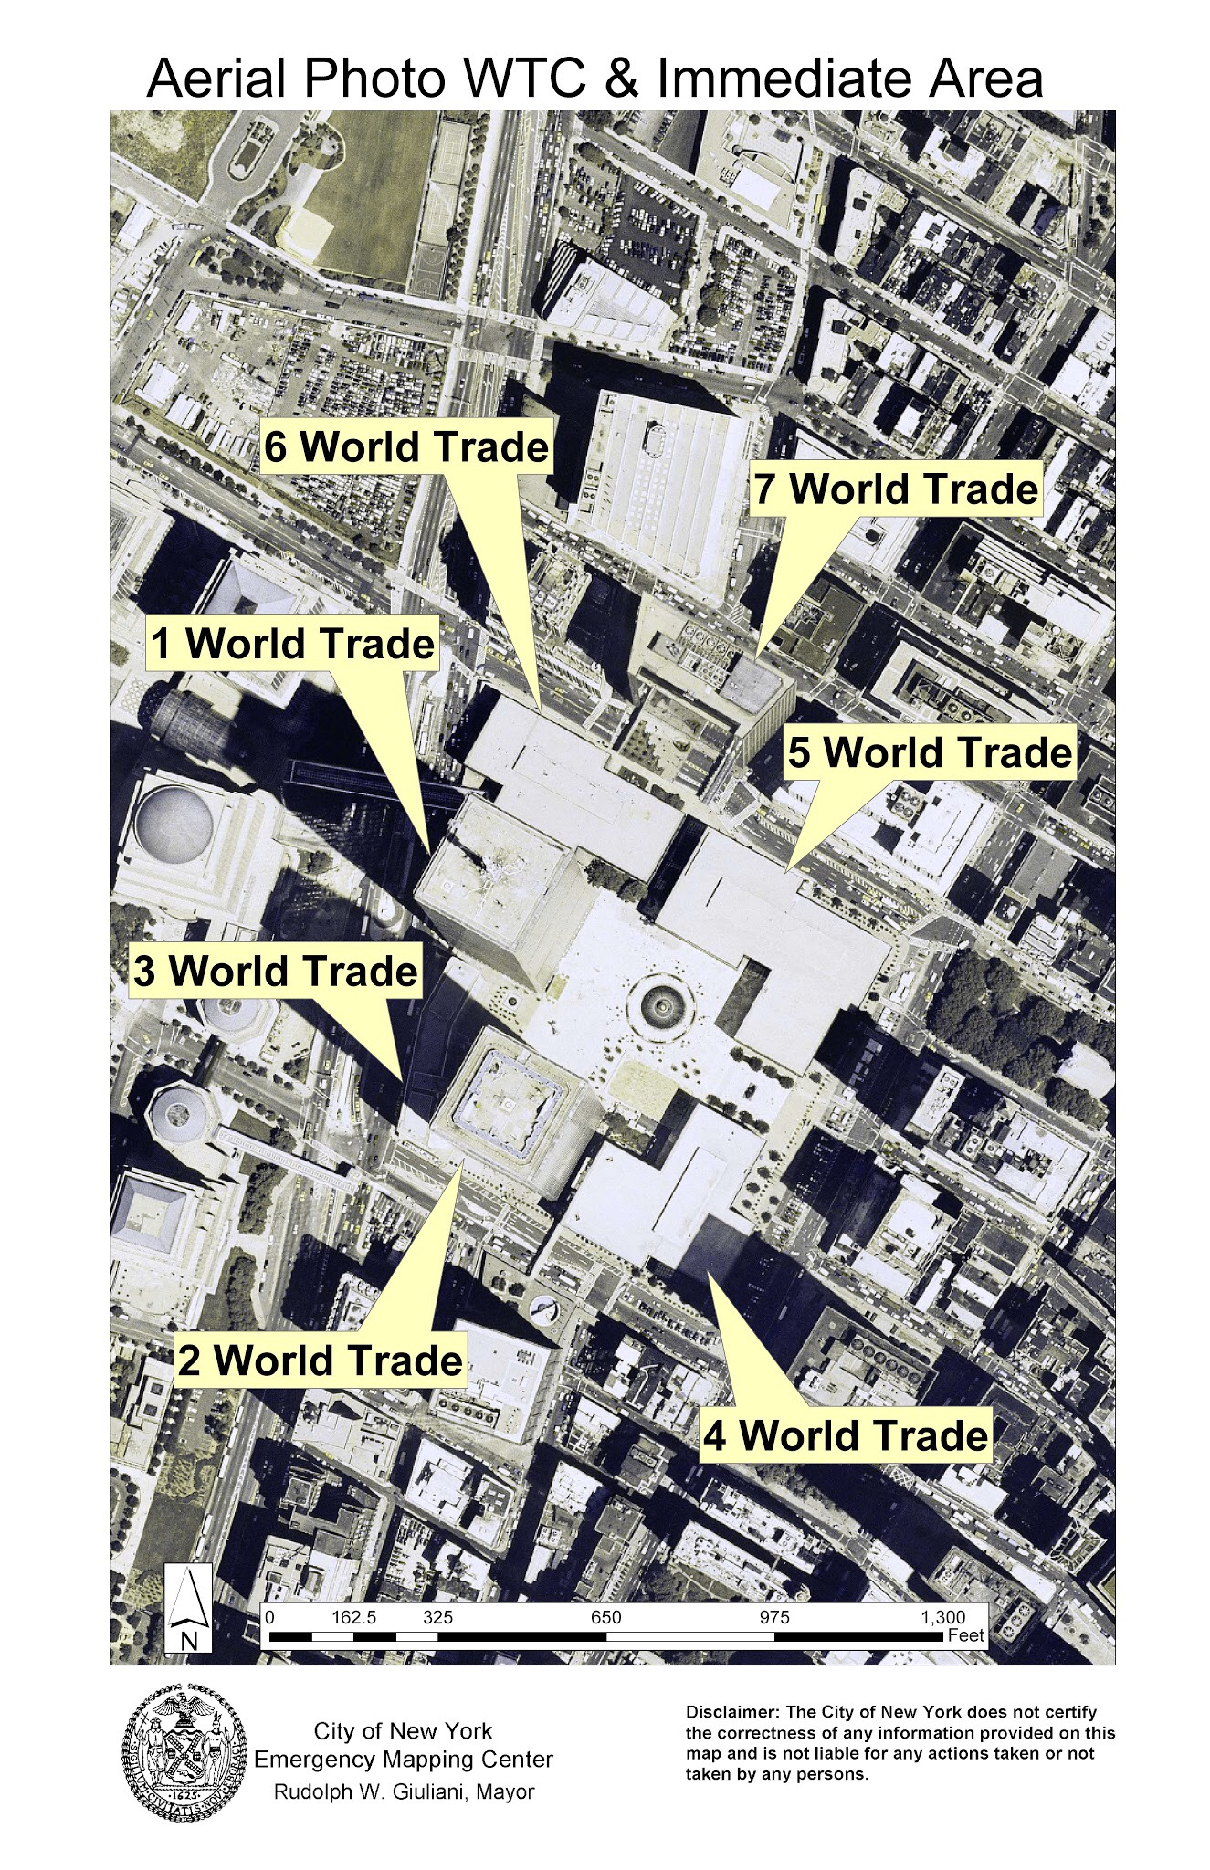

Maps

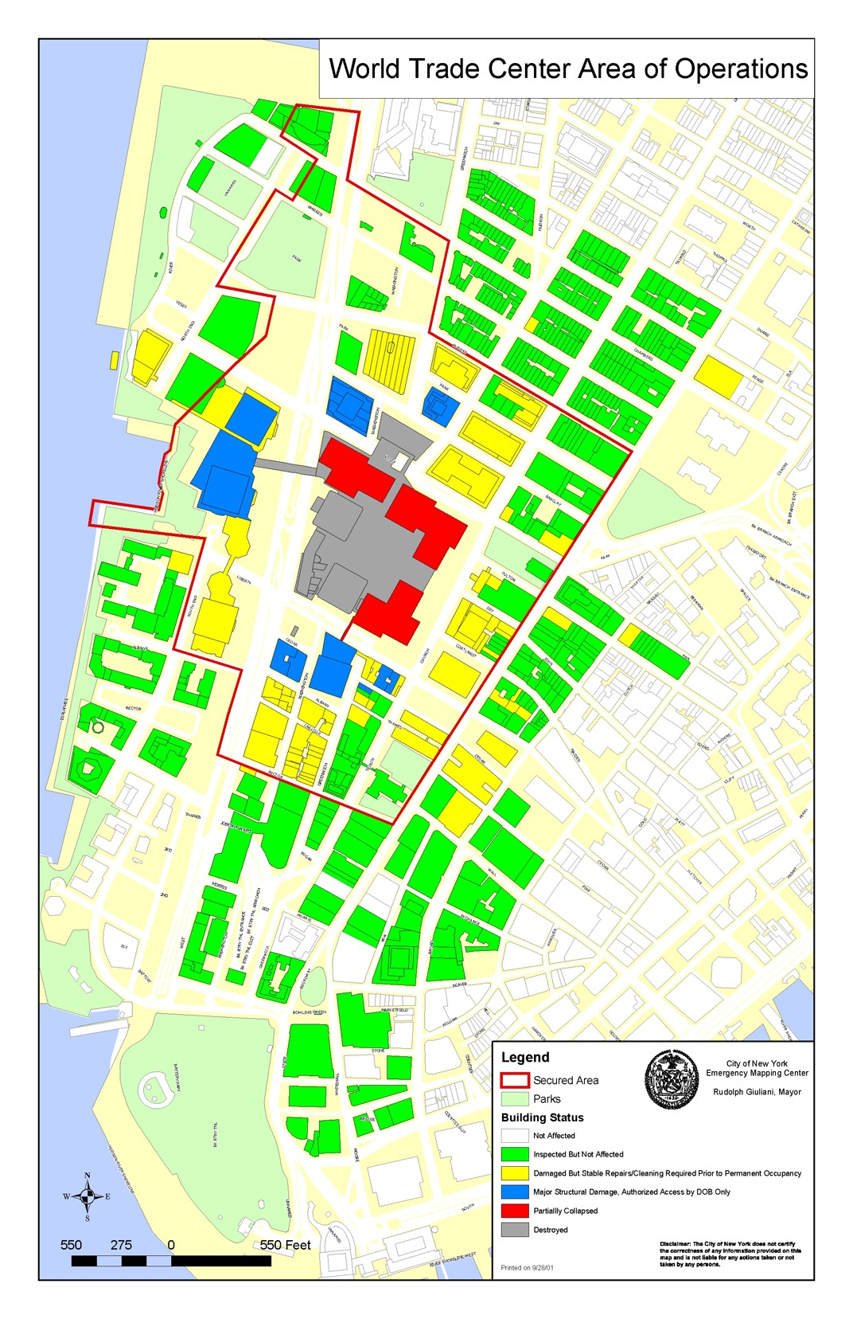

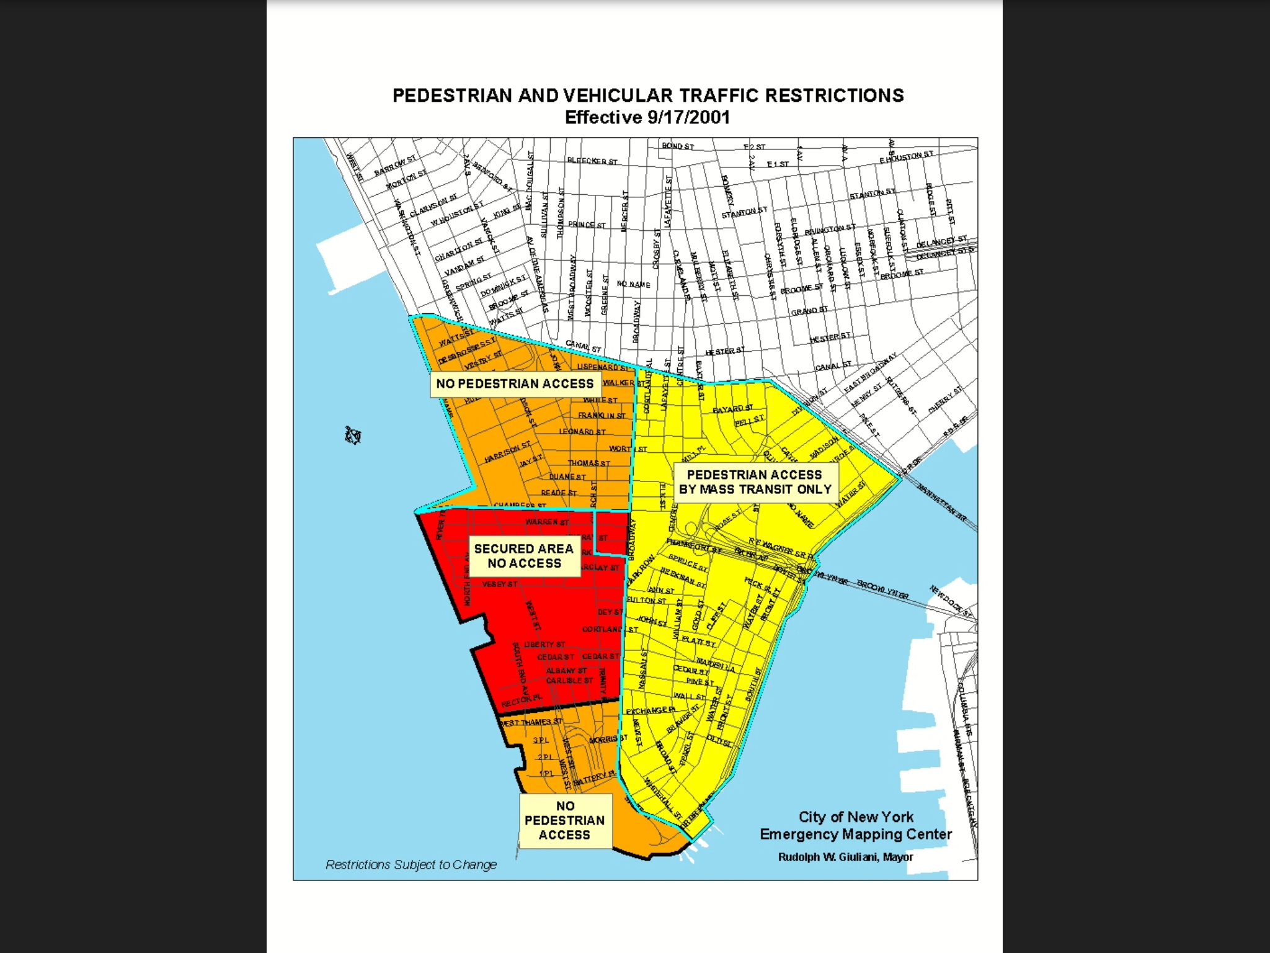

LIDAR imagery and heat maps

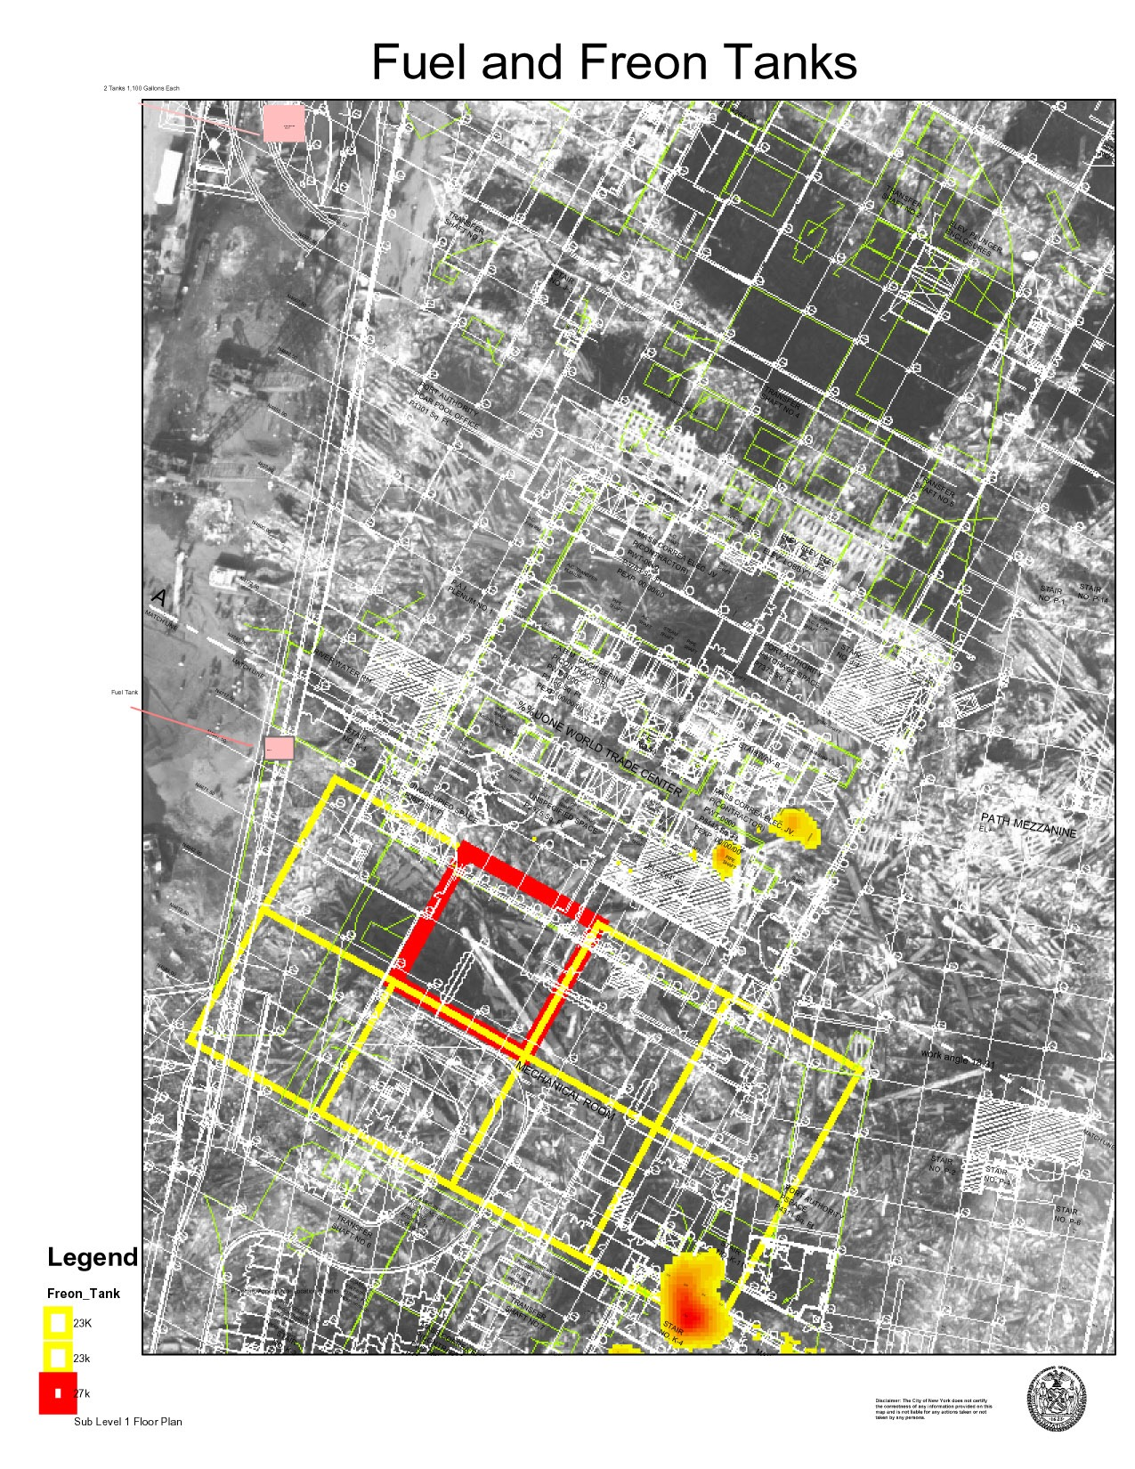

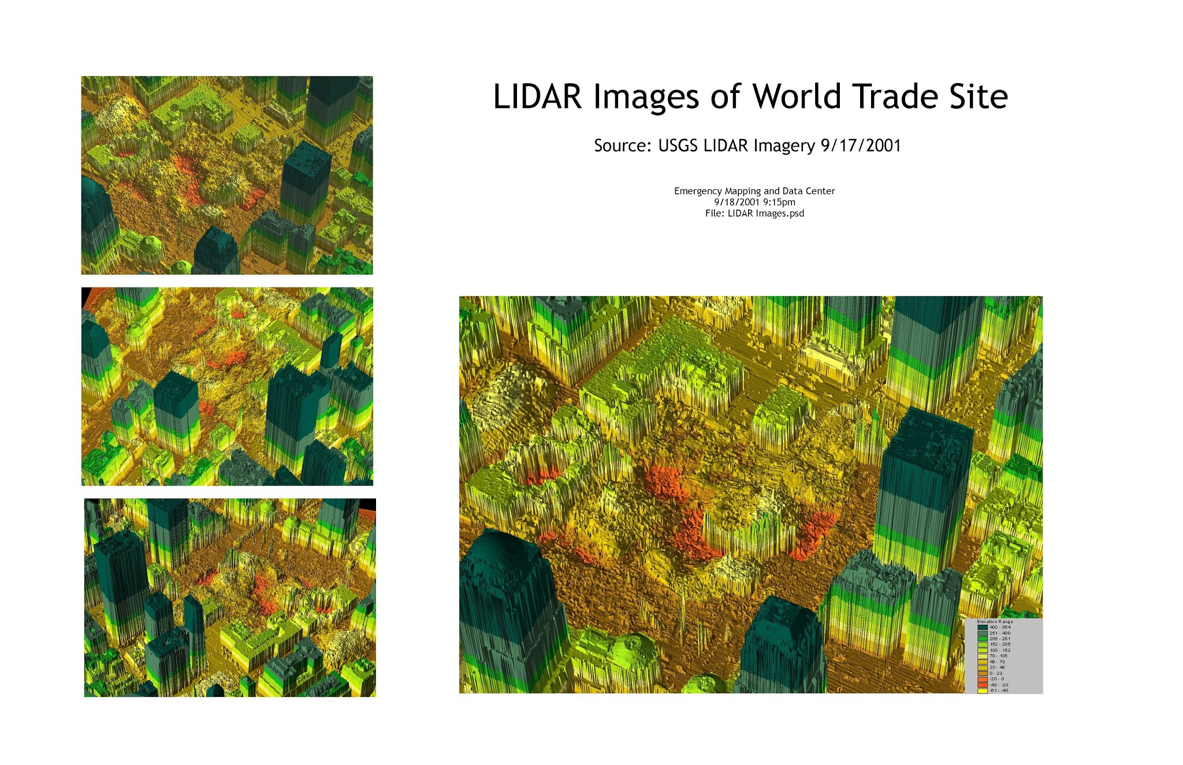

Images from the Emergency Operations Center on Pier 92.

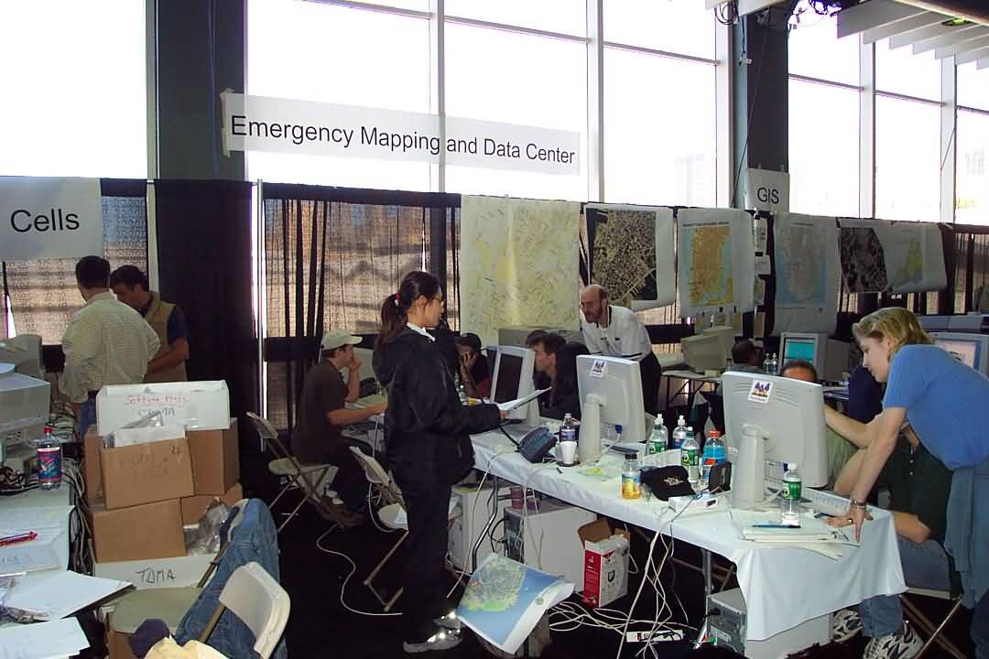

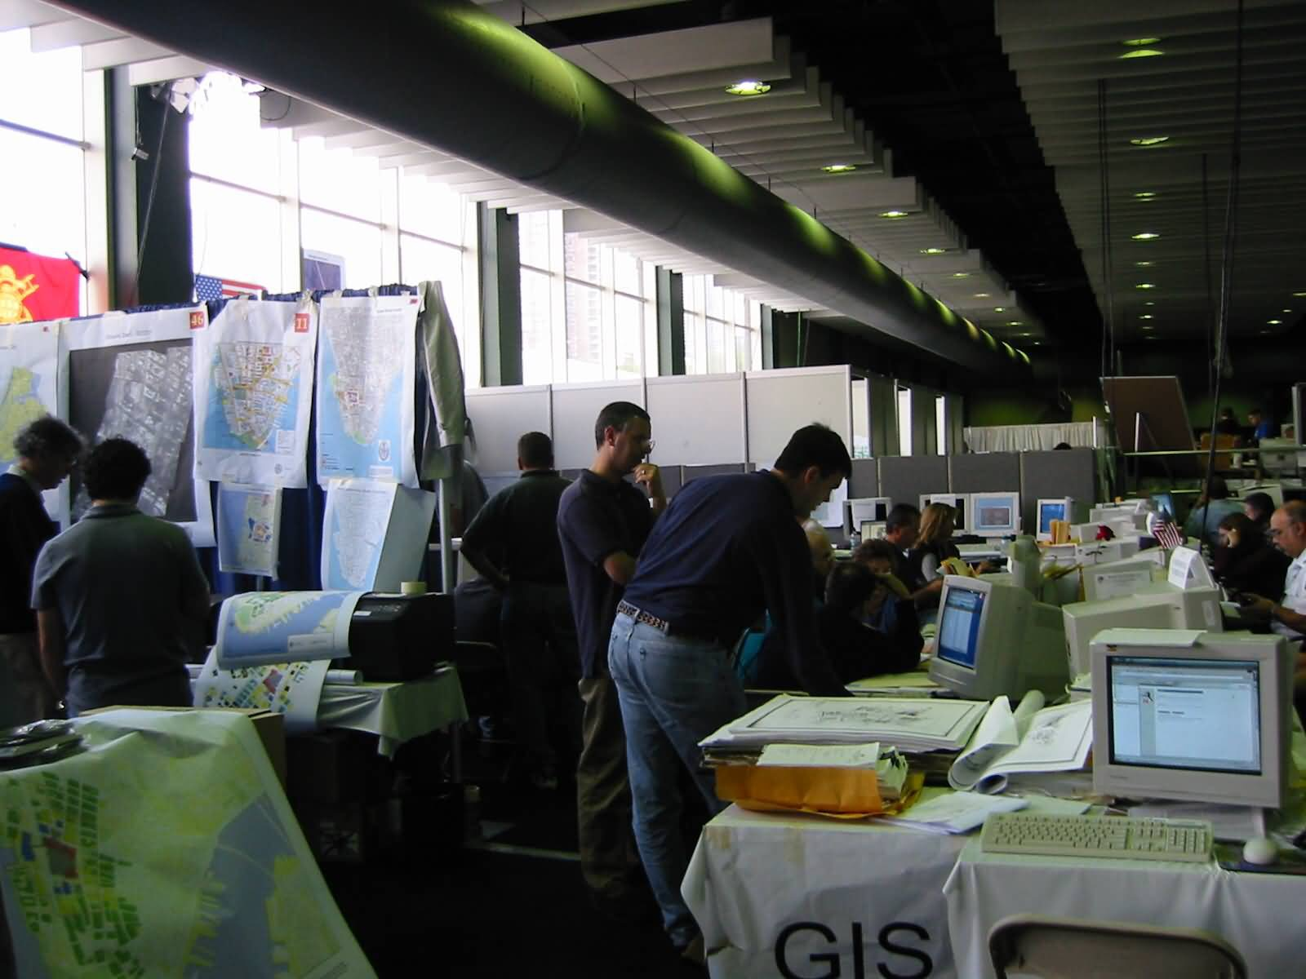

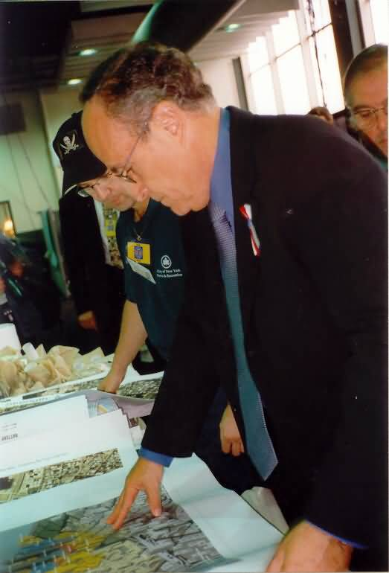

Meeting notes from Department of Environmental Protection: The DEP meetings were the first response coordination meetings, prior to establishing the Emergency Operations Center at Pier 92. The DEP meetings were called when it was clear it was not safe to enter 7 World Trade Center where the OEM offices were located.

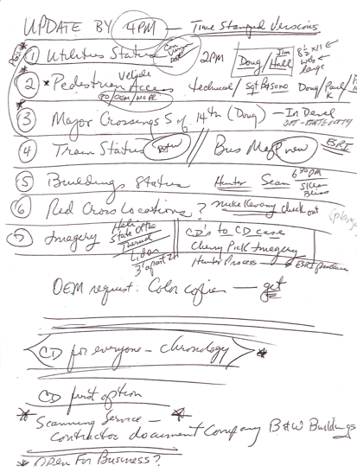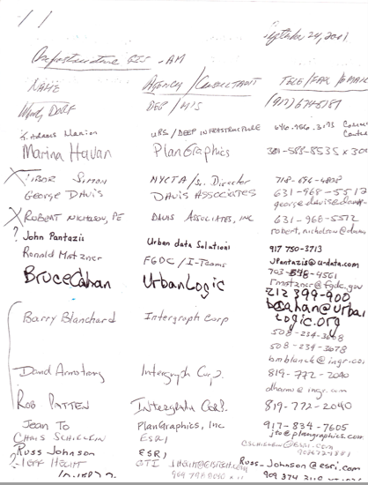

Documents

